Andrés Succar M02 Assignment
Chapter 2 and 3

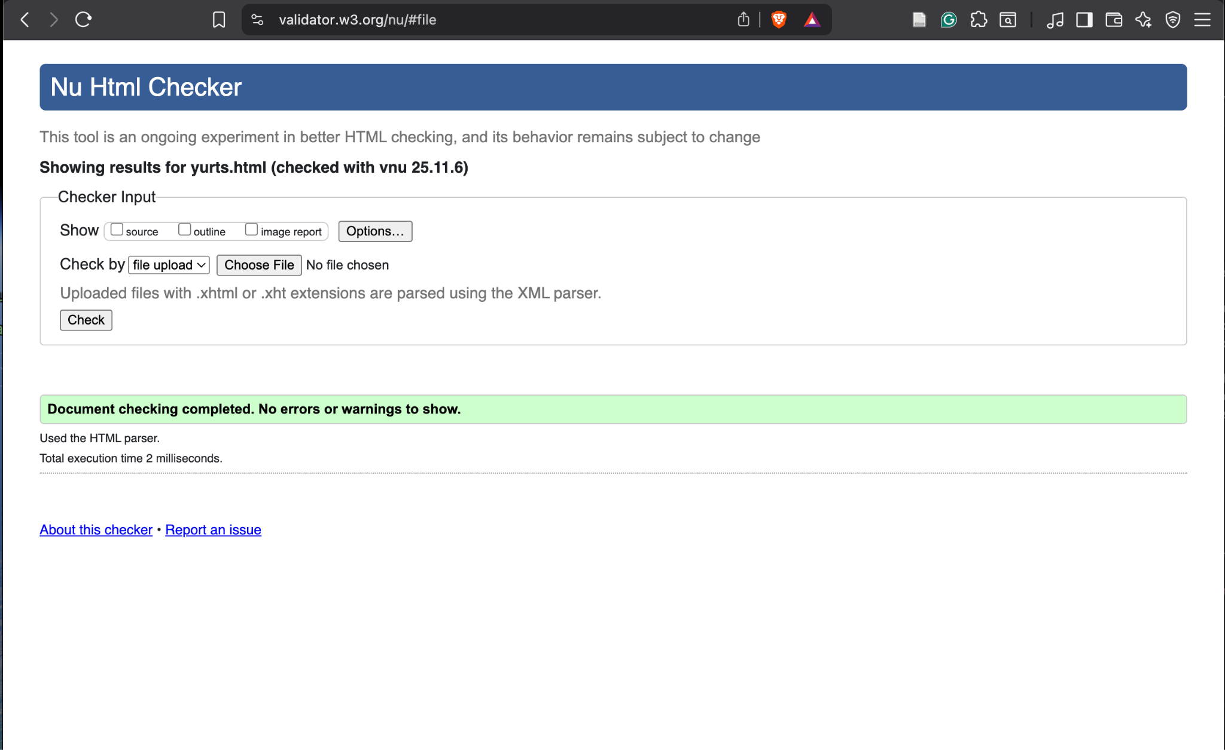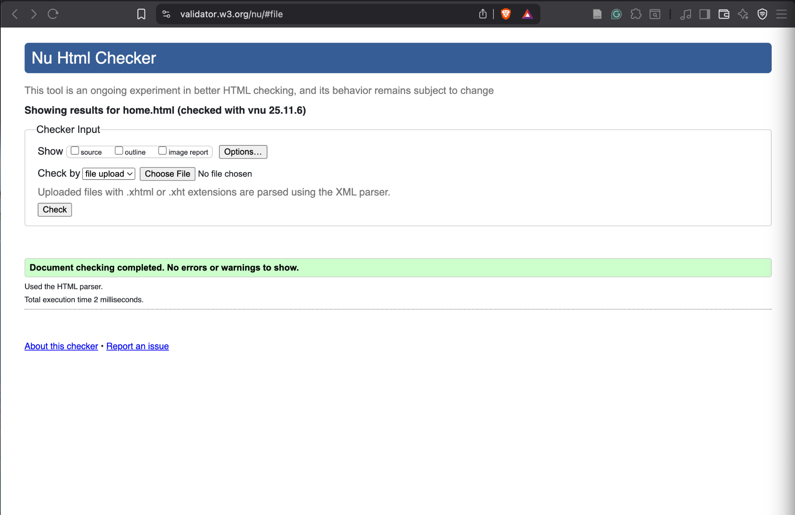

CHAPTER 3
INDEX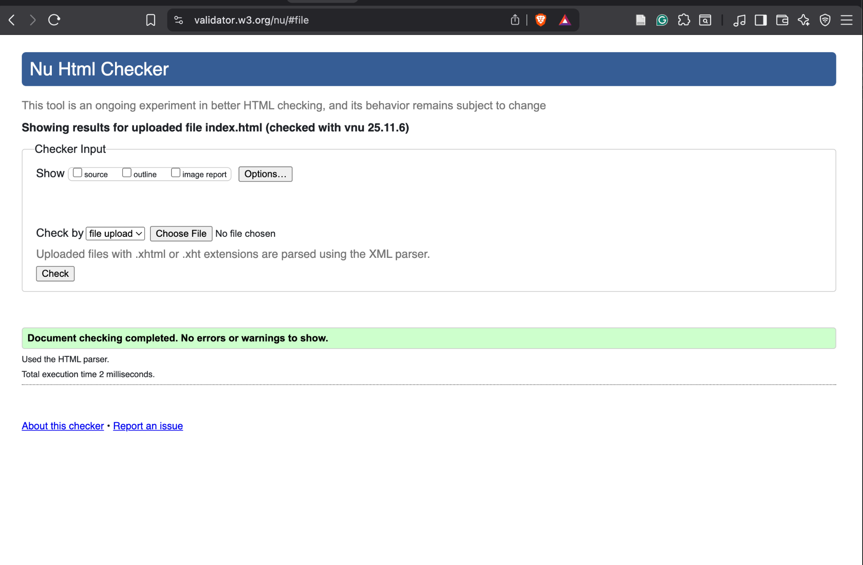

YURTS

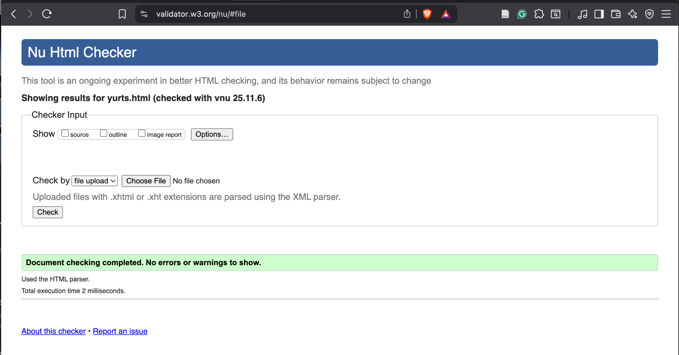
CSS

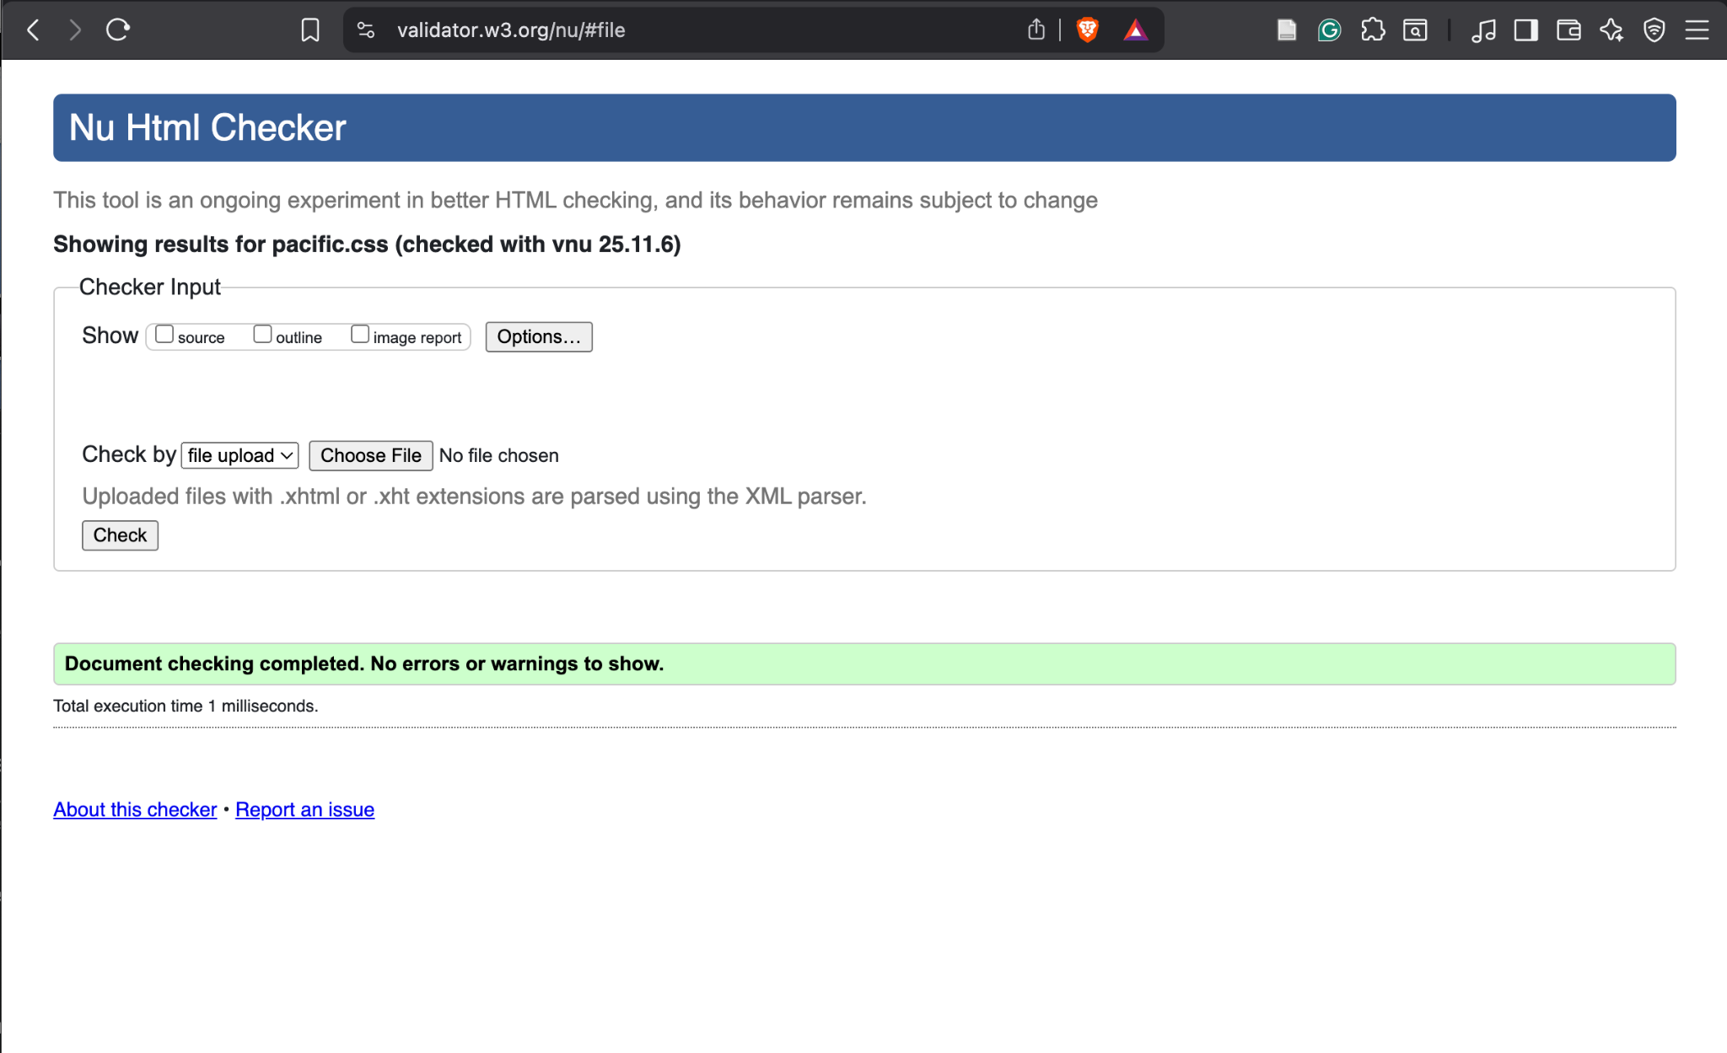

GitHub URL: https://asuccarcuellar-blip.github.io/crispy-enigma/

